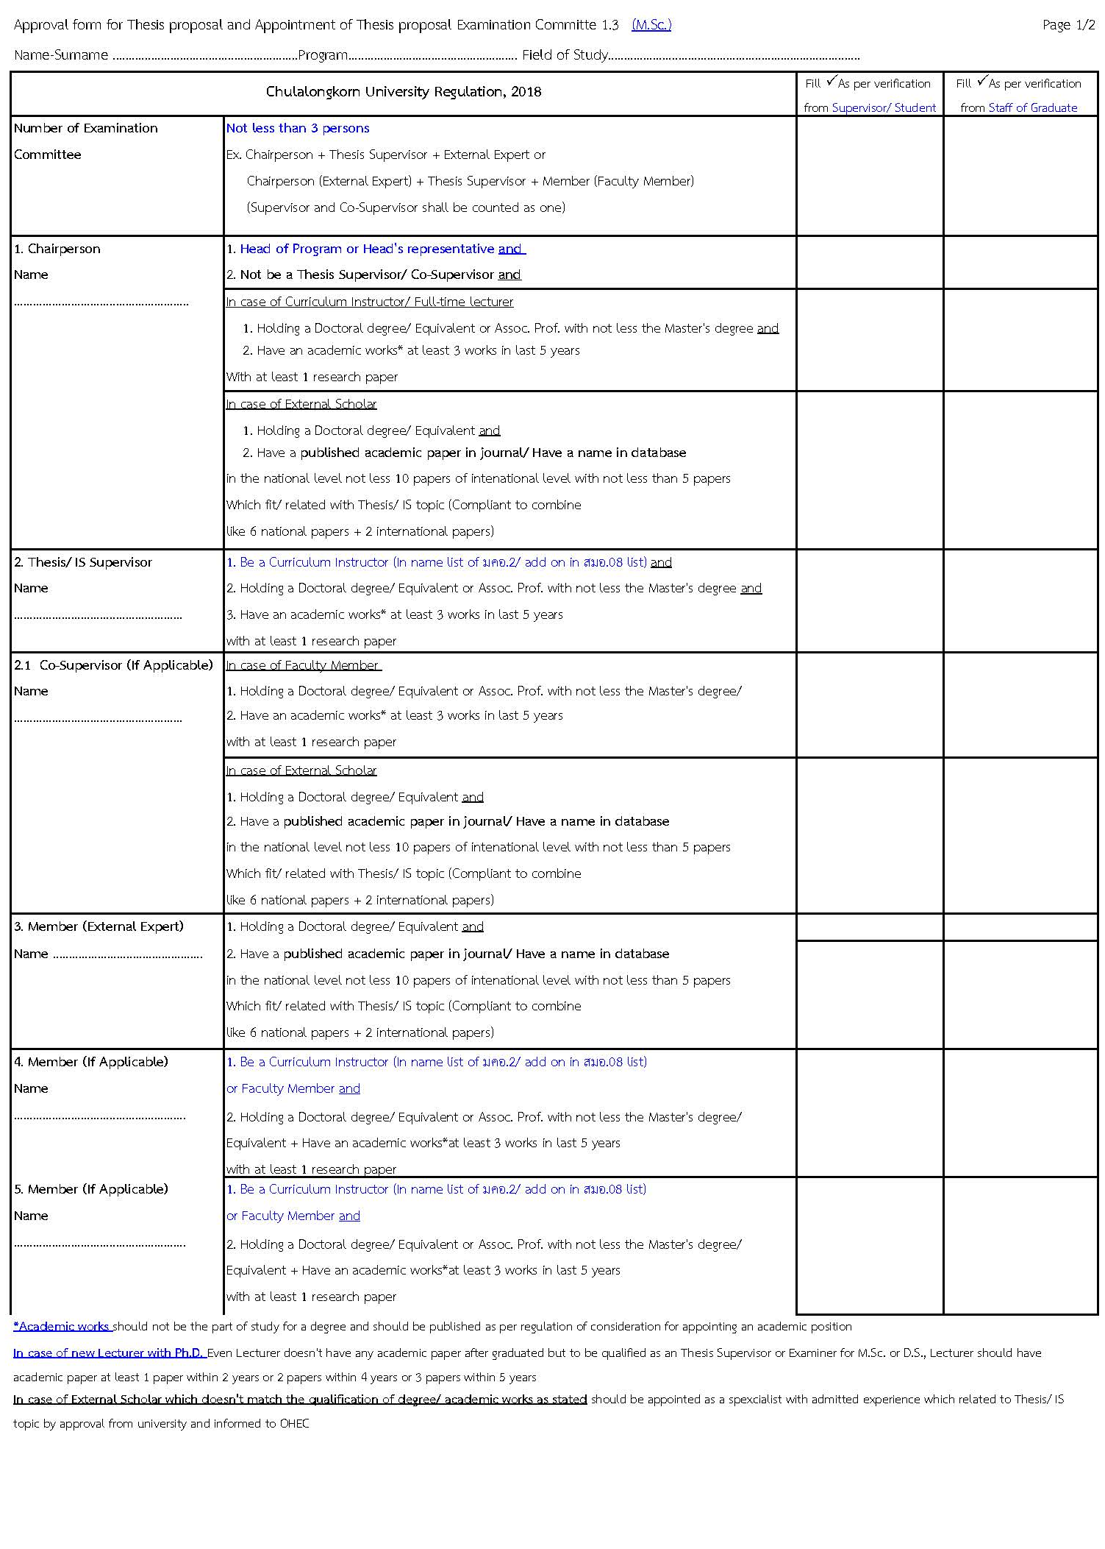

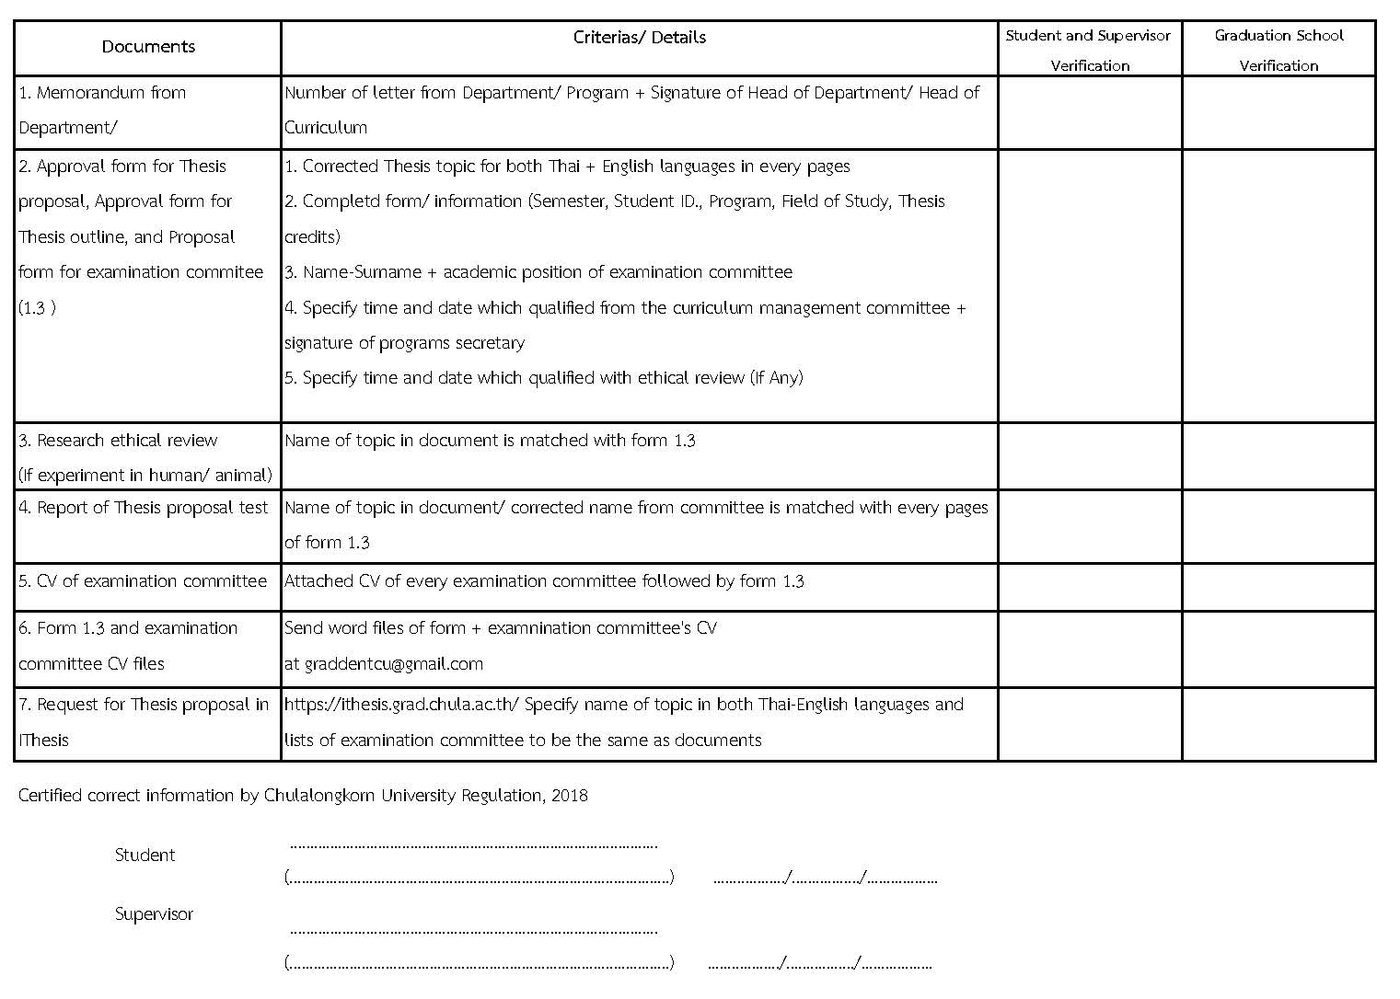

Form 1.3

APPROVAL FORM FOR THESIS PROPOSAL
SUBMITTED TO THE EXECUTIVE BOARD OF FACULTY OF DENTISTRY, CHULALONGKORN UNIVERSITY
□ First □ Second Semester of Academic Year...................
(USE CAPITAL LETTERS ONLY)
*Students are not allowed to alter / change format of this form. If you do not have information for any section of the form, please leave it blank.*
Name - Surname (Mr. / Mrs. / Ms.)………………………………….………………….Student ID…………………………
Department ………………………………Field of Study………………..……….…… Number of Thesis Credits………..
Level of Study □ Master’s □ Doctoral
Study Program □ Normal □ International □ English
Enrolled Since □ First Semester □ Second Semester of Academic Year …….………
Contact Address During Thesis Research …………………………………………………………………………................................................………………………
……………………………..................……………………..Telephone Number ………………............…………..………..
Thesis Title (in Thai) ……………………………………………………………………………………………………………………………..…..
(in English / Use Capital Letters Only) ………………………………………….…….………………………………………………………………………………..
Thesis Supervisor………………………………………………………….. Tel………………………………..
Co-Supervisor (If any)……………...…..…………………………………...Tel.………………………………

Signature ………………………….………….……………. Signature ………………………….………….………..
(Assoc. Prof.Pairoj Linsuwanont, D.D.S., M.D.Sc., Ph.D.) (……………………………………... )
Associate Dean for Graduate Studies Graduate Student
Date ……/………..…/…… Date ……/………..…/……

Signature …………………………………………………… Signature ……..………………….………………………
( ……………………………………………. ) ( ……………………………………………. )
Thesis Supervisor Program Director
Date…… /…..…/……. Date…… /…..…/…….
(For research involving human subjects and/or animal experimentation)
Approved by  Institutional Animal Care and Use Committee Faculty of................................................................................................... in the meeting No................Date …….. / ……………. / ………. as detailed in the attachment  Signature...................................................  (Head of Department/Program Director)  Date .........../................./............... |  Human Research Ethics Committee  Faculty of.............................................................................................. in the meeting No................Date …….. / ……………. / ………. as detailed in the attachment  Signature...................................................  (Head of Department/Program Director)  Date.........../................./..............
Approved by the Program Administrative Committee in the meeting No …………… Date …….. / ……………. / ……….  Signature………………………………………………………  (………………………………………………………….…)  Secretary to the Program Administrative Committee  Date …….. / ……………. / ………. | Approved by the Executive Board of Faculty of Dentistry in the meeting No………………. Date …….. / ……………. / ……….  Signature………………………………………………………  (Kittisak Thotsaporn, Ph.D)  Secretary to the Executive Board of Faculty of Dentistry  Date …….. / ……………. / ……….

APPROVAL FORM FOR THESIS PROPOSAL
SUBMITTED TO THE GRADUATE PROGRAM ADMINISTRATIVE COMMITTEE
(USE CAPITAL LETTERS ONLY)

Name - Surname (Mr. / Mrs. / Ms.)..………………………………………….……………… Student ID …………….………………
Level of Study □ Master’s □ Doctoral
Department ………………………………….……Field of Study…………………..……….… Number of Thesis Credits …..……..
Thesis Title (in Thai) ……………………………………………………………………………………..………..……………………...……..………………..
…………………………………………………………………………………………………………………………….…………..……
(in English / Use Capital Letters Only) ………………………………………….…….…………………………………………………………………..………………………..
……………………………………………………………………………………………………………………………………..………
Thesis Supervisor……………………………………………….………..…………… Tel. ……………………………………………
Co-Supervisor (If Any) …………………..………………….….………….………… Tel. …………........…………...………………
Objectives
……………………………………………………………………………………………………………………………….…………….
……………………………………………………………………………………………………………………………………………..
…………………………………………………………………………………………………………………………………………….
……………………………………………………………………………………………………………………………….…………….
……………………………………………………………………………………………………………………………………………. ……………………………………………………………………………………………………………………………….…………….
……………………………………………………………………………………………………………………………………………..
…………………………………………………………………………………………………………………………………………….
……………………………………………………………………………………………………………………………….…………….
…………………………………………………………………………………………………………………………………………….
Rationale and Hypotheses
…………………………………………………………………………………………………………………………………………….
…………………………………………………………………………………………………………………………………………….
……………………………………………………………………………………………………………………………….……………
…………………………………………………………………………………………………………………………………………….
……………………………………………………………………………………………………………………….……………….......
………………………………………………………………………………………………………………………….…………………
…………………………………………………………………………………………………………………………...…..……………
……………………………...........................................................................................................................................................................
……………………………………………………………………………………………………………………….……………………
………………………………………………………………………………………………………………………….…………………
Detailed Research Procedures and Methods
Please Draw Straight Lines in the Blank Space Numbering 1 to 18 to Represent the Lengths of Time for the Various Steps for the Conduct of Research

(Month and Year the Research Starts ………………) | 1 | 2 | 3 | 4 | 5 | 6 | 7 | 8 | 9 | 10 | 11 | 12 | 13 | 14 | 15 | 16 | 17 | 18

Expected Benefits
- ……………………………………………………………………………………………………………………………………………………………………………………………………………………………………………………………….
- ……………………………………………………………………………………………………………………………………………………………………………………………………………………………………………………………….
- ………………………………………………………………………………………….……………………………………………………………………………………………………………………………………………………………………

Signature ……………………………………………………….. Graduate Student
(……………………………………………)
Date…………./……………./…………….

REQUEST FOR APPOINTMENT OF THESIS EXAMINATION COMMITTEE
SUBMITTED TO GRADUATE PROGRAM ADMINISTRATIVE COMMITTEE AND EXECUTIVE BOARD OF FACULTY OF DENTISTRY
(USE CAPITAL LETTERS ONLY)

Name - Surname (Mr. / Mrs. / Ms.)………………………………………….……………… Student ID ………………………
Level of Study □ Master’s □ Doctoral
Department ………………………………………Field of Study………………..……….… Number of Thesis Credits ………..
Thesis Title (in Thai) ………………………………………………………………………………………..………………………………………..
……………………………………………………………………………………………………………………………..……
(in English / Use Capital Letters Only) ………………………………………….…….…………………………………………………………………………………..
……………………………………………………………………………………………………………………………..………
List of Thesis Examination Committee Members
…………………………………………………….................. Chairperson
…………………………………………………….................. Thesis Supervisor
………………………………………….…………................. Co-Supervisor (If Any)
……………………………………………………………….. Member
……………………………………………………………….. Member
……………………………………………………………….. External Member

Signature ………………………….………….……………. Signature ………………………….………….………..
(Assoc. Prof.Pairoj Linsuwanont, D.D.S., M.D.Sc., Ph.D.) (……………………………………... )
Associate Dean for Graduate Studies Graduate Student
Date ……/………..…/…… Date ……/………..…/……

Signature ………………………………………………… Signature………..………………….…………………
( …………………………….………. ) ( …………………………….……… )
Thesis Supervisor Program Director
Date ……/………..…/…… Date……/………..…/……

Approved by the Program Administrative Committee in the meeting no. …………… Date …….. / ……… / …….  Signature …………………………………………………….  ( …………………………………………… )  Secretary to the Program Administrative Committee  Date …….. / ……………. / ………. | Approved by the Executive Board of Faculty of Dentistry in the meeting no ……………Date …….. / ……… / ……….  Signature ……………………………………………………  (Kittisak Thotsaporn, Ph.D)  Secretary to the Executive Board of Faculty of Dentistry  Date…….. / ……………. / ……….

