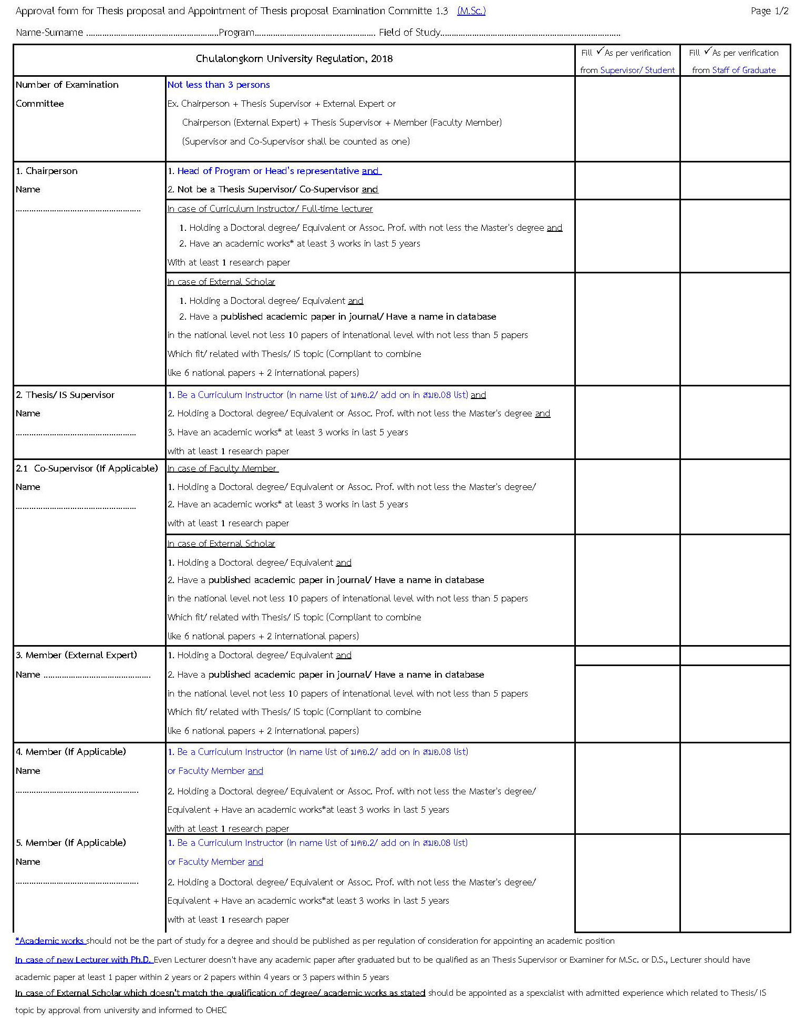

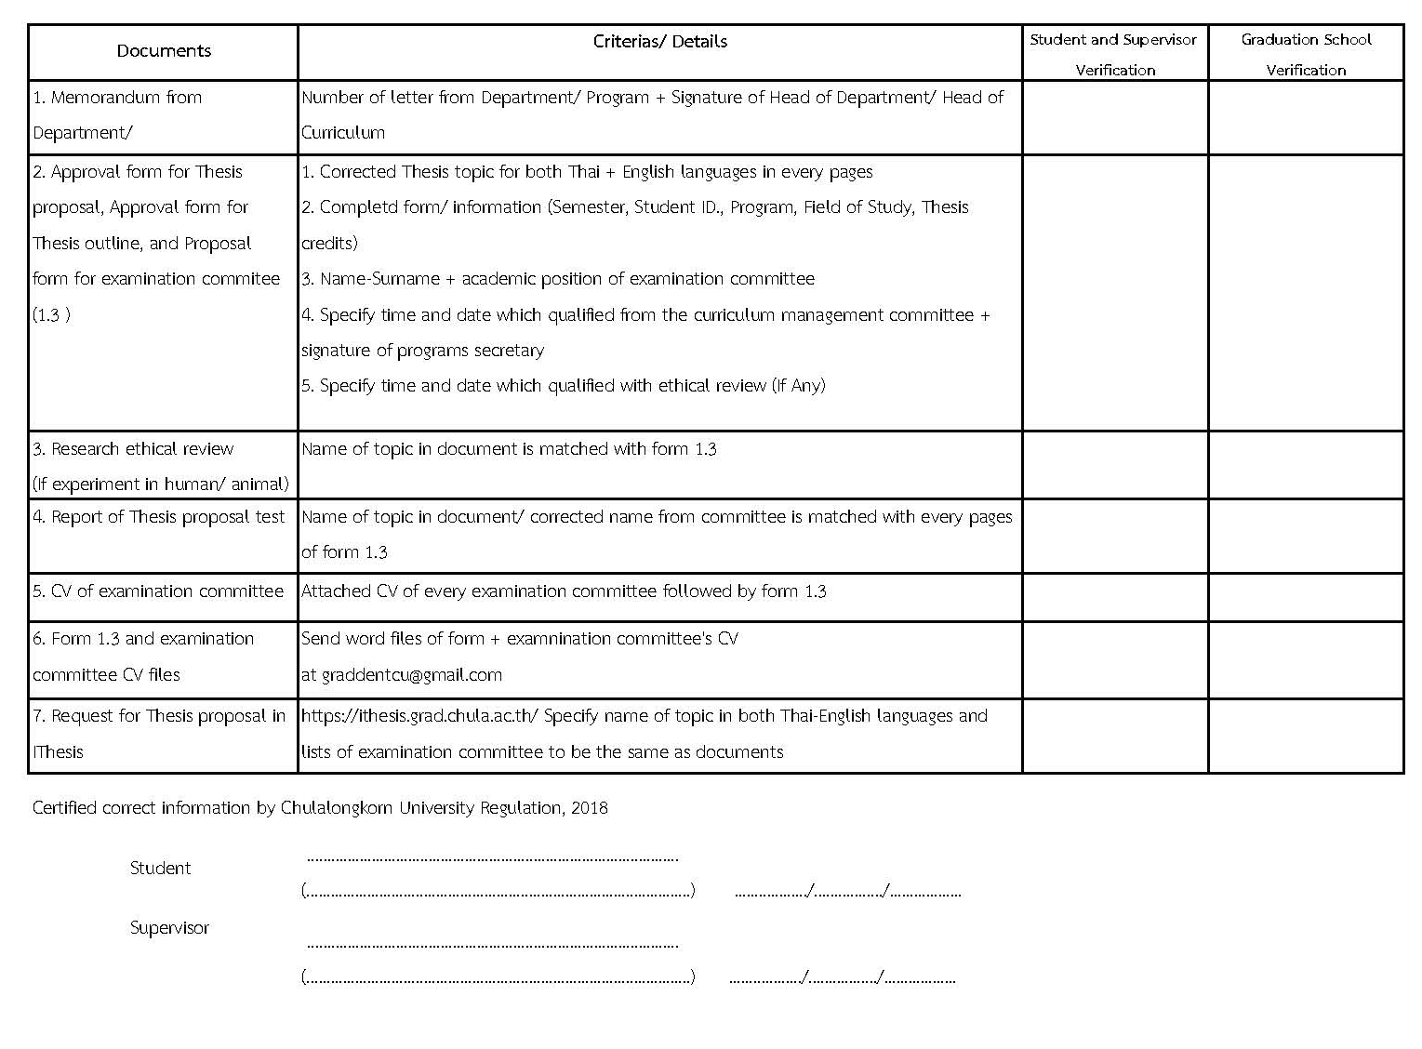

Form 1.3

APPROVAL FORM FOR THESIS PROPOSAL
SUBMITTED TO THE EXECUTIVE BOARD OF FACULTY OF DENTISTRY, CHULALONGKORN UNIVERSITY
□ First □ Second Semester of Academic Year.................
(USE CAPITAL LETTERS ONLY)
*Students are not allowed to alter / change format of this form. If you do not have information for any section of this form, please leave it blank.*
Name - Surname (Mr. / Mrs. / Ms.)………………………………….……………….…Student ID…………………………
Department ………………………………Field of Study………………..……….…… Number of Thesis Credits………..
Level of Study □ Master’s □ Doctoral
Study Program □ Normal □ International □ English
Enrolled Since □ First Semester □ Second Semester of Academic Year …….…………
Contact Address During Thesis Research …………………………………………………………………………................................................……………………….
……………………………..................……………………..Telephone Number ………………............…………..…………
Thesis Title (in Thai) ……………………………………………………………………………………………………………………………..…
(in English / Use Capital Letters Only) ………………………………………….…….…………………………………………………………………………………..
Thesis Supervisor……...……………………………………………………...Tel.………………………………
Co-Supervisor (If any)….....……………..……………………………………Tel.………………………………

Signature ………………………….………….……………. Signature ………………………….………….………..
(Assoc. Prof.Pairoj Linsuwanont, D.D.S., M.D.Sc., Ph.D.) (……………………………………... )
Associate Dean for Graduate Studies Graduate Student
Date ……/………..…/…… Date ……/………..…/……

Signature …………………………………………………… Signature……..………………….……………………..
( …………………………….……… ) ( …………………………….………… )
Thesis Supervisor Program Director
Date ……/………..…/…… Date …… /..……….. /…….
** Research that does not require approval of Ethic Committee is the sole responsibility of main thesis supervisor

Approved by the Program Administrative Committee in the meeting No. ……………. Date …….. / ……………. / ……….  Signature …………………………………………………………..  (………………………………………………………….…)  Secretary to the Program Administrative Committee  Date …….. / ……………. / ………. | Approved by the Executive Board of Faculty of Dentistry in the meeting No. ………………. Date …….. / ……..…. / ……….  Signature …………………………………………………………….  (Kittisak Thotsaporn, Ph.D)  Secretary to the Executive Board of Faculty of Dentistry  Date …….. / ……………. / ……….

APPROVAL FORM FOR THESIS PROPOSAL
SUBMITTED TO THE GRADUATE PROGRAM ADMINISTRATIVE COMMITTEE
(USE CAPITAL LETTERS ONLY)

Name - Surname (Mr. / Mrs. / Ms.)..………………………………………….……………… Student ID …………….………………
Level of Study □ Master’s □ Doctoral
Department ………………………………….……Field of Study…………………..……….… Number of Thesis Credits …..……..
Thesis Title (in Thai) ……………………………………………………………………………………..………..……………………...……..………………..
…………………………………………………………………………………………………………………………….…………..……
(in English / Use Capital Letters Only) ………………………………………….…….…………………………………………………………………..………………………..
……………………………………………………………………………………………………………………………………..………
Thesis Supervisor……………………………………………….………..…………… Tel. ……………………………………………
Co-Supervisor (If Any) …………………..………………….….………….………… Tel. …………........…………...………………
Objectives
……………………………………………………………………………………………………………………………….…………….
……………………………………………………………………………………………………………………………………………..
…………………………………………………………………………………………………………………………………………….
……………………………………………………………………………………………………………………………….…………….
……………………………………………………………………………………………………………………………………………. ……………………………………………………………………………………………………………………………….…………….
……………………………………………………………………………………………………………………………………………..
…………………………………………………………………………………………………………………………………………….
……………………………………………………………………………………………………………………………….…………….
…………………………………………………………………………………………………………………………………………….
Rationale and Hypotheses
…………………………………………………………………………………………………………………………………………….
……………………………………………………………………………………………………………………………….…………….
……………………………………………………………………………………………………………………………………………..
…………………………………………………………………………………………………………………………………………….
……………………………………………………………………………………………………………………………….…………….
…………………………………………………………………………………………………………………………………………….
……………………………………………………………………………………………………………………………….…………….
……………………………………………………………………………………………………………………………………………..
Detailed Research Procedures and Methods
Please Draw Straight Lines in the Blank Space Numbering 1 to 18 to Represent the Lengths of Time for the Various Steps for the Conduct of Research

(Month and Year the Research Starts ………………) | 1 | 2 | 3 | 4 | 5 | 6 | 7 | 8 | 9 | 10 | 11 | 12 | 13 | 14 | 15 | 16 | 17 | 18

Expected Benefits
- ………………………………………………………………………………………………………………………………………………………………………………………………………
- ………………………………………………………………………………………………………………………………………………………………………………………………………
- ………………………………………………………………………………………………………………………………………………………………………………………………………
- ………………………………………………………………………………………………………………………………………………………………………………………………………
- ………………………………………………………………………………………….……………………………………………………………………………………………………………

Signature ……………………………………………………….. Graduate Student
(……………………………………………)
Date…………./……………./…………….

REQUEST FOR APPOINTMENT OF THESIS EXAMINATION COMMITTEE
SUBMITTED TO GRADUATE PROGRAM ADMINISTRATIVE COMMITTEE AND EXECUTIVE BOARD OF FACULTY OF DENTISTRY
(USE CAPITAL LETTERS ONLY)

Name - Surname (Mr. / Mrs. / Ms.)………………………………………….……………… Student ID ………………………
Level of Study □ Master’s □ Doctoral
Department …………………………………Field of Study……………..……….… Number of Thesis Credits ………….…..
Thesis Title (in Thai) ………………………………………………………………………………………..…………………………………………..
……………………………………………………………………………………………………………………………....……
(in English / Use Capital Letters Only) ………………………………………….…….…………………………………………………………………………………..
……………………………………………………………………………………………………………………………..………
List of Thesis Examination Committee Members
…………………………………………………….................. Chairperson
…………………………………………………….................. Thesis Supervisor
………………………………………….…………................. Co-Supervisor (If Any)
……………………………………………………………….. Member
……………………………………………………………….. Member
……………………………………………………………….. External Member

Signature ………………………….………….……………. Signature ………………………….………….………..
(Assoc. Prof.Pairoj Linsuwanont, D.D.S., M.D.Sc., Ph.D.) (……………………………………... )
Associate Dean for Graduate Studies Graduate Student
Date ……/………..…/…… Date ……/………..…/……

Signature ………………………………………………… Signature………..………………….…………………
( …………………………….………. ) ( …………………………….……… )
Thesis Supervisor Program Director
Date ……/………..…/…… Date……/………..…/……
Approved by the Program Administrative Committee in the meeting no. …………… Date …….. / ……… / …….  Signature …………………………………………………….  ( …………………………………………… )  Secretary to the Program Administrative Committee  Date …….. / ……………. / ………. | Approved by the Executive Board of Faculty of Dentistry in the meeting no ……………Date …….. / ……… / ……….  Signature ……………………………………………………  (Kittisak Thotsaporn, Ph.D)  Secretary to the Executive Board of Faculty of Dentistry  Date…….. / ……………. / ……….

